**Landing page**

1. Adjust SIGN UP display



1. Remove animation for Feature section in landing page
2. A. Make the font size bigger and clearer.

B. Remove the animation for central PowerBox logo. Just keep it for upload and download

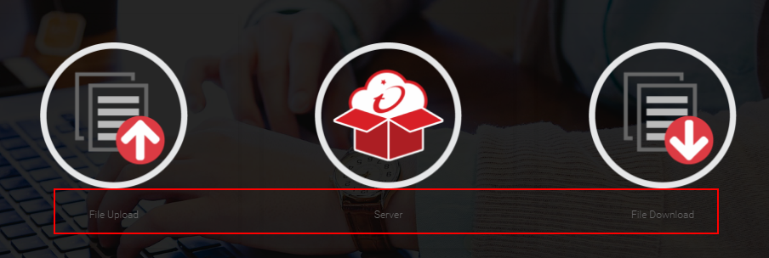

**Features page**

This page looks a bit too simple.

1. Bigger the font size
2. Change the image for each feature
3. Remove the animation for this page

Sample: <https://www.box.com/security>

**Security page**

1. Same as landing page point #3

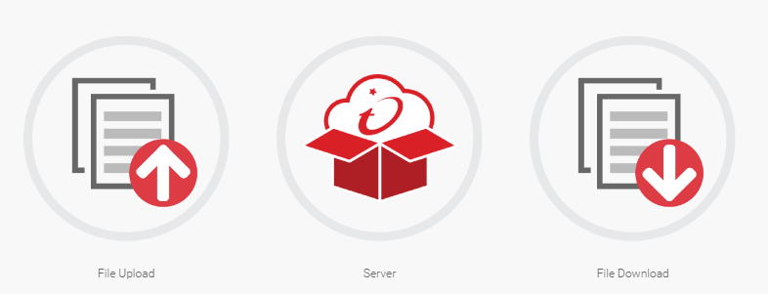

1. Remove all animation for this page
2. Bigger the description font size
3. Switch the order of the display, let Trend Micro display first.

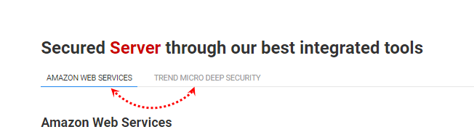

1. Make this bug smaller, it’s way too big

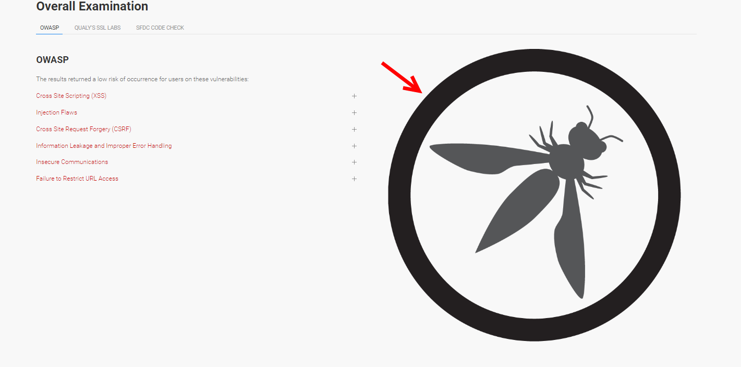

**Integration page**

1. Replace SFDC logo with this one:



1. Replace Zendesk logo with this one:



1. Maybe use a carousel effect to display powerbox and SFDC? (not sure how to look nice, maybe you have better ideas?)

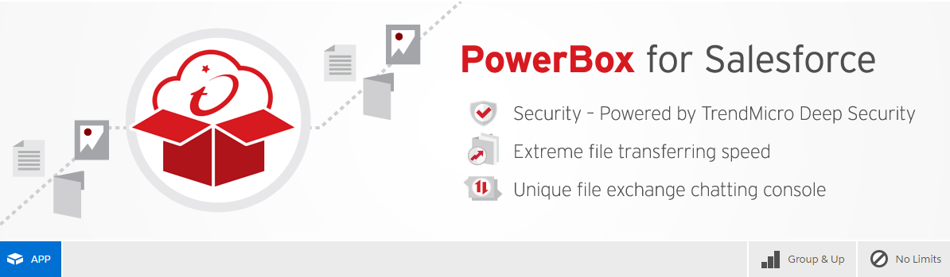

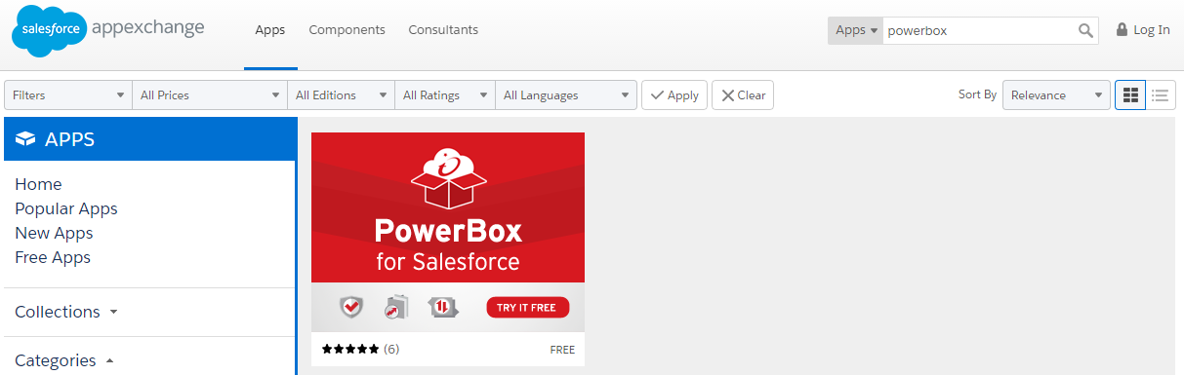

**About Us**

1. I try to find some pictures relative with the word we put. You are very welcome to put something better than mine :P

left



center



Right

https://fd-resource.s3.amazonaws.com/pic0.png This is the logo of Trend Education Foundation, not sure if it’s suits here….

1. Put two more rows on the picture display.